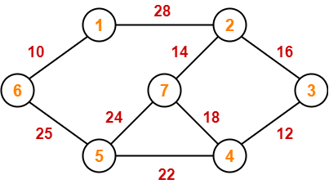

Solution-

The above discussed steps are followed to find the minimum cost spanning tree using Prim’s Algorithm-

Step-01:

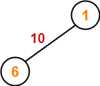

Step-02:
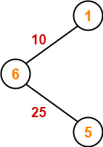

Step-03:

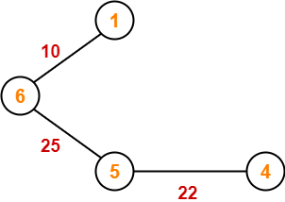

Step-04:

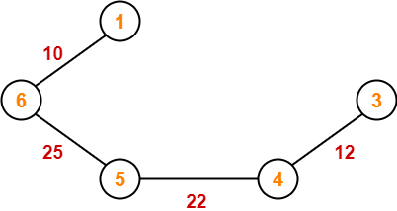

Step-05:

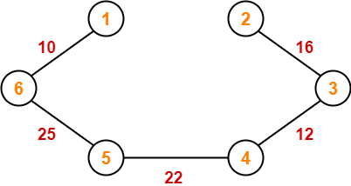

Step-06:

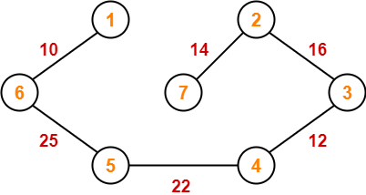

Since all the vertices have been included in the MST, so we stop.

Now, Cost of Minimum Spanning Tree
= Sum of all edge weights
= 10 + 25 + 22 + 12 + 16 + 14
= 99 units

Spanning tree - A spanning tree is the subgraph of an undirected connected graph.
Minimum Spanning tree - Minimum spanning tree can be defined as the spanning tree in which the sum of the weights of the edge is minimum. The weight of the spanning tree is the sum of the weights given to the edges of the spanning tree.
Using Prim’s Algorithm, find the cost of minimum spanning tree (MST) of the given graph-

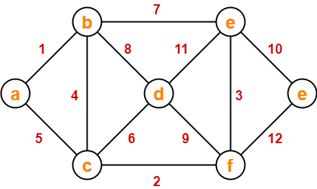

Solution-

The minimum spanning tree obtained by the application of Prim’s Algorithm on the given graph is as shown below-

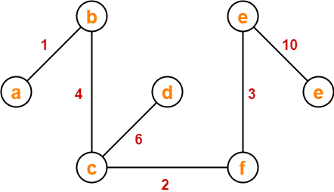

Now, Cost of Minimum Spanning Tree
= Sum of all edge weights
= 1 + 4 + 2 + 6 + 3 + 10
= 26 units

